Experiment Number : 8 Date: 12-2-2026

Implementation of Packages in Java

Aim:
Write a Java program to implement built-in, user-defined packages and accessing all classes in a package.

PRE LAB EXERCISE
QUESTIONS
- What is java.util package and what collection framework does it contain?
java.util is a built-in Java package that provides utility classes for handling data and common operations.
It contains the Collection Framework, which includes interfaces like List, Set, Queue, Map and classes such as ArrayList, LinkedList, HashSet, HashMap, TreeMap, etc., used to store and manage groups of objects.
- What are the two types of packages in Java?
- Built-in Packages – Predefined packages provided by Java (e.g., java.lang, java.util, java.io).
- User-defined Packages – Packages created by programmers using the package keyword to organize classes.

IN LAB EXERCISE
Objective
To understand and implement the concepts of built-in, user-defined packages and accessing all classes in a package in Java.
Built-in Packages comprise a large number of classes that are part of the Java API. Some of the commonly used built-in packages are:
- java.lang: Contains language support classes(e.g, classes that define primitive data types, math operations). This package is automatically imported.
- java.io: Contains classes for supporting input/output operations.
- java.util: Contains utility classes that implement data structures such as Linked Lists and Dictionaries, as well as support for date and time operations.
- java.applet: Contains classes for creating Applets.
- java.awt: Contains classes for implementing the components for graphical user interfaces (like buttons, menus, etc).
Source Code
import java.util.Random; // built-in package
public class Sample{
public static void main(String[] args) {
// using Random class
Random rand = new Random();
// generates a number between 0–99
int number = rand.nextInt(100);
System.out.println("Random number: " + number);
}
}
Output
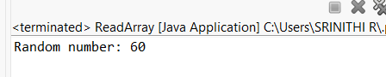
User-defined Packages are the packages that are defined by the user.
Source code
package com.myapp;
public class Helper {
public static void show() {
System.out.println("Hello from Helper!");
}
}
==To use this in another class==
import com.myapp.Helper;
public class Test {
public static void main(String[] args) {
Helper.show();
}
}

Output:
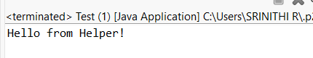
//Importing all classes from a package.
Source code
import java.util.Vector;
public class Coders {
public Coders() {
// java.util.Vector is imported, We are able to access it directly in our code.
Vector v = new Vector();
java.util.ArrayList l = new java.util.ArrayList();
l.add(3);
l.add(5);
l.add(7);
System.out.println(l);
}
public static void main(String[] args) {
new Coders();
}
}
Output
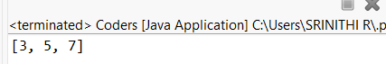
POST LAB EXERCISE
- What will happen if two classes in different packages have the same name and are imported in a Java file?
It creates a compile-time ambiguity error because the compiler cannot decide which class to use.
To resolve this, you must use the fully qualified name (e.g., packageName.ClassName) instead of importing both.
- What is the purpose of using packages in Java?
Packages are used to:
- Organize related classes and interfaces into groups
- Avoid naming conflicts
- Provide better access control
- Improve code management and reusability

- Which built-in Java package would you use if you want to create a GUI window and display a message?
- java.util
- java.sql
- java.awt
- java.net
C. java.awt
It contains classes like Frame, Label, and Button used to build GUI applications.

ASSESSMENT

Description | Max Marks | Marks Awarded
Pre Lab Exercise | 5
In Lab Exercise | 10
Post Lab Exercise | 5
Viva | 10
Total | 30
Faculty Signature

